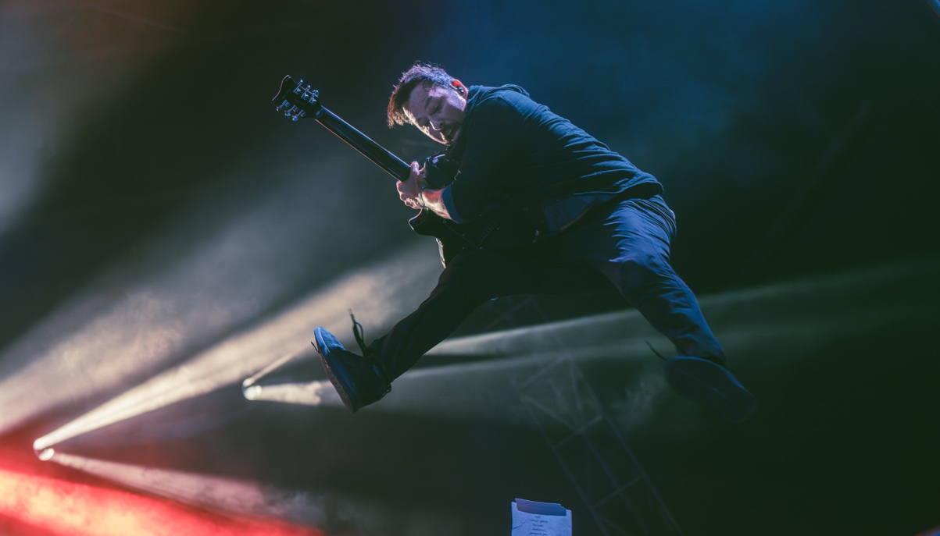

Photo Credit: Matt DeBenedictis

Sennheiser Gear Survives the Pit: Furnace Fest 2025 Relies on Durability and Clarity for High-Energy Audio

Legendary Hardcore Festival Chooses Sennheiser e 835, MD 421 Kompakt, and evolution Series Instrument Mics to Manage 98 Bands and Unpredictable Stage Environments

Birmingham, Alabama — Nov. 6, 2025 — Furnace Fest, the three-day music festival celebrating hardcore, emo, and metal, successfully navigated its 2025 return in Birmingham, Alabama, powered by a reliable audio package from Sennheiser. Faced with a demanding lineup of 98 bands, rapid changeovers, and the genre's famously unpredictable energy, the festival’s Head of Audio Josh Ford recognized that only Sennheiser could deliver the crucial blend of sonic performance and field-tested durability.

Furnace Fest’s production challenge was immense but not impossible: maintain aggressive, high-SPL (Sound Pressure Level) audio quality across multiple stages while ensuring the gear could withstand the physical demands of performers who often engage directly with the crowd. Ford, who grew up in the DIY hardcore scene, understood the unique chaos. “Hardcore festivals are pretty unpredictable,” Ford shared. “I’ve had mics get thrown out in the crowd and shatter upon impact. In that instance, having to run on stage and patch up a mic is less than ideal and can kill the vibe momentarily.”

Typical festival pressure was compounded by tight changeovers and a critical radio frequency interference incident caused by a nearby football stadium broadcast. The festival team required gear that performed consistently and minimized the need for major console adjustments for the wide variety of touring engineers. Ford, who is also the Production Manager for the festival’s home venue, stated, "It was a massive relief knowing the gear could reliably handle nearly 100 acts across three days, even when battling those stadium frequency conflicts. It gave us the confidence we needed and helped that part of the day be completely painless."

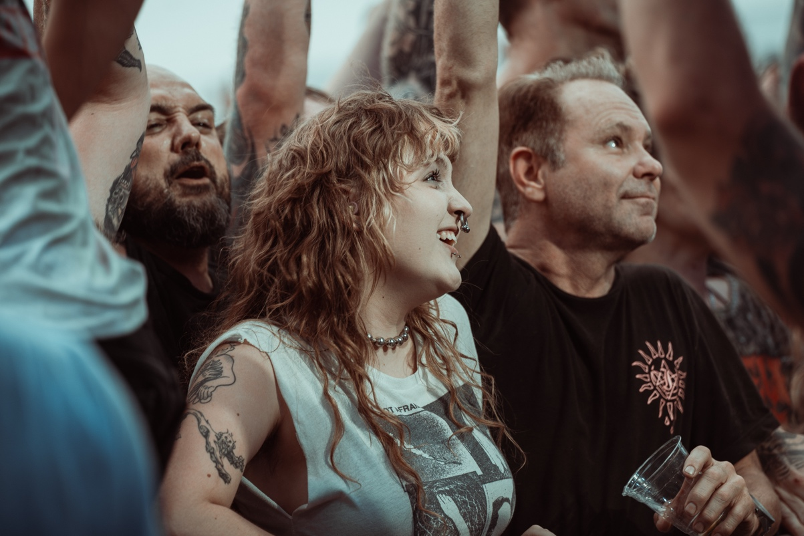

In an environment where crowd experience is crucial, Sennheiser’s stage mics kept vocals crisp and instruments defined. Photo Credit: Matt DeBenedictis

To meet high stakes demands, Ford and his team deployed a comprehensive package of Sennheiser wired and wireless solutions, whose consistent quality and minimal need for EQ adjustments greatly simplified the intense changeover process. The Sennheiser evolution series e 835 was deployed as the primary vocal microphone on the main stage, chosen specifically for its ability to handle extreme vocal dynamics. “It’s a great choice for the festival genres and comes in especially handy for bands that tend to do more screaming,” Ford shared. “It can handle a high SPL level. The capsule simply doesn't break up as badly as others. We were all excited with how the vocals ended up sounding for several of the sets that I mixed.” For vocalists requiring greater freedom on stage, the tighter polar pattern of the e 935 helped minimize cymbal and drum bleed.

Sennheiser’s instrument microphones proved essential for accurately capturing the complex, aggressive sounds of the backline. Ford utilized the MD 421 Kompakts on toms and even took a chance using it on a snare drum. “I captured quite possibly one of the best snares sounds I’ve ever gotten off of a mic,” Ford stated. “I knew it was durable and could take a hit without the clip sliding off. Once I set the angle, it stayed there the whole day — truly revolutionary.” The e 906 and e 609 were used consistently for guitar cabs, and the e 604s were used on the drum kit, with Ford crediting these instrument mics for ensuring rapid changeovers.

The gear's reputation for ruggedness and high-quality sound was validated by the touring production teams. Lucas Kozinski, FOH for Microwave, detailed their specific microphone choices, "For Microwave, we utilize the e904's on toms for their incredible reliability. I know they can take a ton of stick hits without losing connectivity or any integrity or frequency response. One rehearsal day, we did a mic shootout for Nate's vocals, and we landed on the e945. It was the best option for receiving his distorted vocal chain that he'll use in heavier parts of songs.”

Travis Wade, FOH for Dillinger Escape Plan and Suicidal Tendencies, added: “Sennheiser products have remained a constant for me at both club shows, as well as festivals. Their durability, reliability, customer support, and product quality really helps me accomplish my goals, especially with an intense and sometimes chaotic show.” For Suicidal Tendencies, the drum kit is powered by Sennheiser e604 microphones on the toms, while frontman Mike Muir commands the stage with an e935 vocal mic paired with the EW 500 G4 wireless system. The Dillinger Escape Plan’s setup reflects the same commitment to precision, employing e604 and e904 drum mics, the EW 500 G4 for vocals, EW-DX wireless instrument systems, and EW G4 IEMs to keep every performance tightly synced and sonically balanced.

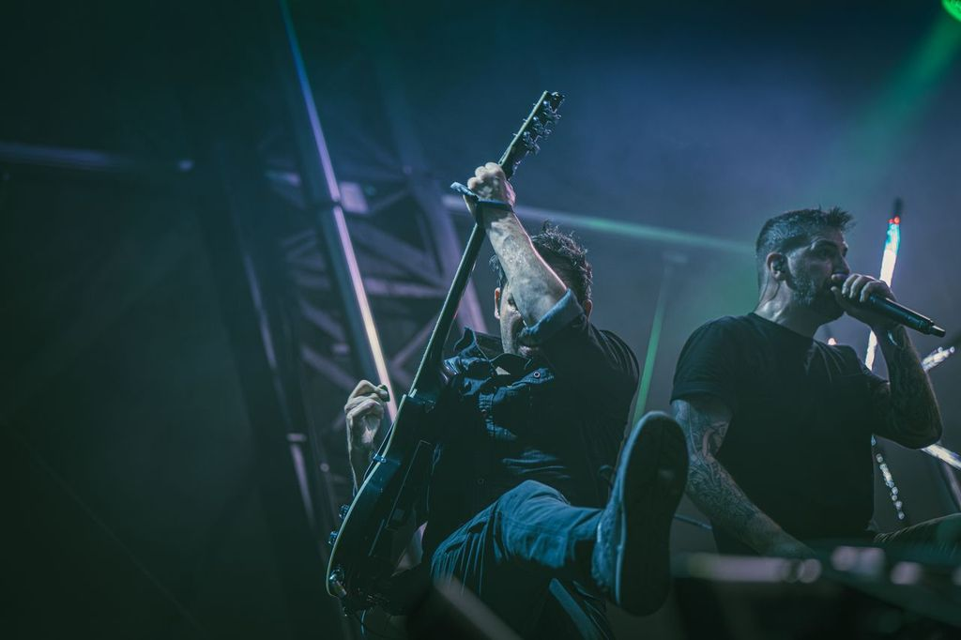

Thanks to the EW-DX Wireless System’s vocal mic, every guttural scream was captured by with forensic precision during the Dillinger Escape Plan’s set, transforming raw chaos into sonic clarity. Photo Credit: Matt DeBenedictis

The essential combination of wireless performance and audio fidelity was echoed by the performers themselves. Chase Brenneman, guitar player for Comeback Kid, noted the gear's reliability at a high-stakes event like Furnace Fest: "Our Sennheiser wireless IEMs and mics have been solid at every festival — clear sound, reliable connection, and built to handle long, loud days on stage. They make setup easy and keep the focus on the music, not the gear."

Beyond the microphones, the production team relied on Sennheiser G4 wireless units for in-ear monitoring, a standard that touring engineers universally welcome. The entire package provided an excellent starting point, with touring engineers powering up the console, hearing a sound they were happy with, and proceeding directly to performance without needing major technical intervention. This efficiency was key to maintaining the tight schedule.

“The most common piece of positive feedback was that it worked, plain and simple,” Ford stated. “In my experience, Sennheiser equipment has always been excellent to work with. It sounds great and it’s durable, and in live music that’s paramount. On the backend, we always need to know if the equipment can take a beating and still work. The team felt electrified seeing that the microphone could be thrown out into the crowd and come back in one piece.”

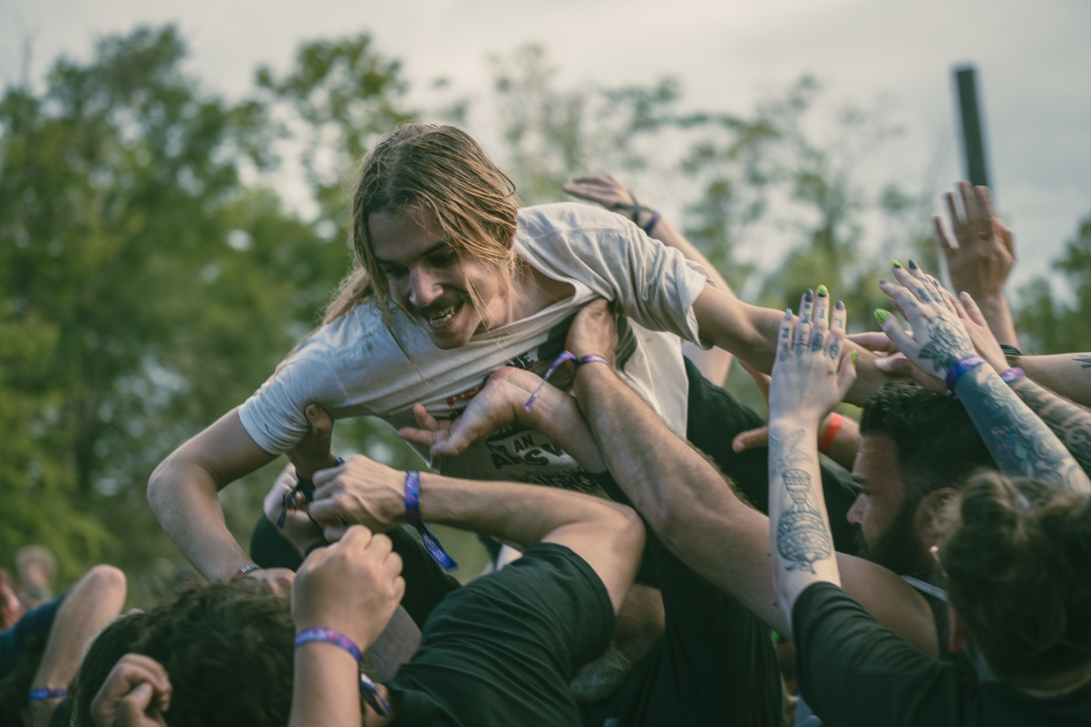

The roar of the crowd met the precision of Sennheiser microphones, proving that even in the most intense festival settings, detail and dynamics can coexist. Photo Credit: Matt DeBenedictis

Ford concluded, "It was an incredible experience! Unlike past experiences where vendors struggled with delivery, everything with Sennheiser was smooth, easy, and on time. Knowing that this is a relationship we can count on is not only reassuring — it also has our wheels already turning for their partnership in next year’s festival.” Ultimately, the reliability and performance of Sennheiser's gear have cemented the festival’s audio achievement, establishing a new standard for quality that will indefinitely keep Furnace Festival a hot topic throughout the industry.
For more information on Sennheiser, please visit Sennheiser.com.

###

About the Sennheiser brand
We live and breathe audio. We are driven by the passion to create audio solutions that make a difference. Building the future of audio and bringing remarkable sound experiences to our customers – this is what the Sennheiser brand has represented for more than 75 years. While professional audio solutions such as microphones, meeting solutions, streaming technologies and monitoring systems are part of the business of Sennheiser electronic GmbH & Co. KG, the business with consumer devices such as headphones, soundbars and speech-enhanced hearables is operated by Sonova Holding AG under the license of Sennheiser.

www.sennheiser.com
www.sennheiser-hearing.com

Local Press Contacts:
Daniella Kohan
daniella.kohan@sennheiser.com
+1 (860) 227-2235

Peter Schuyler
Peter@ingearpr.com
+1 (917) 496-8970

